Task 7: Create a dockerfile, docker-compose file which when executed must display your basic details in the website.

Solution:

I had a website with my basic details, written a docker and docker compose file , displayed website on ports 3000.

dockerfile

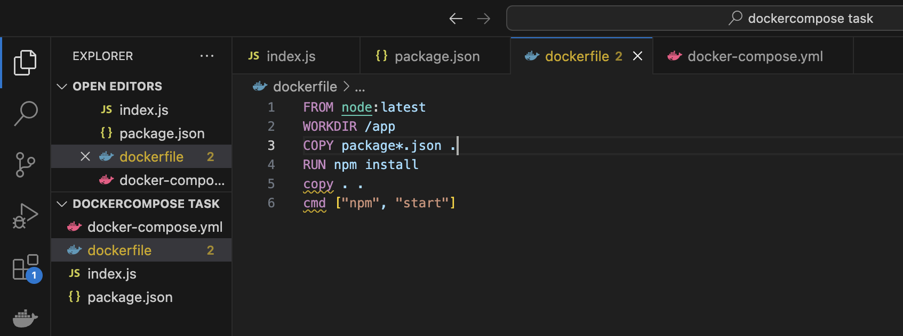

Docker-compose file  
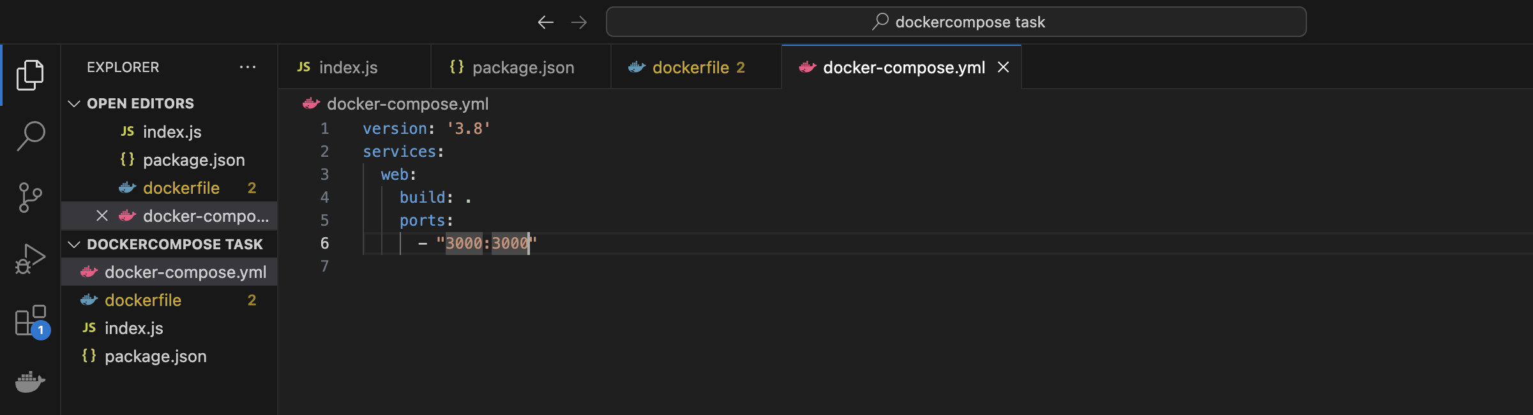  
running containers using docker-compose up –-build

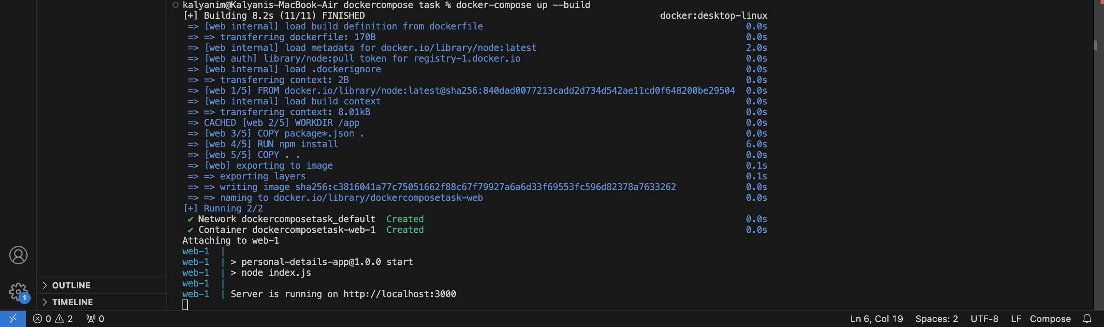

Basic details displayed in <http://localhost:3000/>

